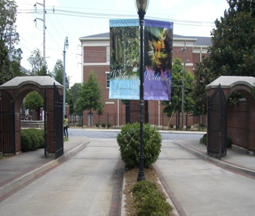

Domestic Exchange Checklist
Visiting Students

This form must be typed and returned to the email addresses noted below. Select the option in the drop down menu in the status column or typing your response to the item. For example, click on the shaded gray field/box that says fall and the option of spring will appear. Similarly, if you click on the shaded grey field/box that reads accepted the option decline will appear.

Name: Home School: Term of Study:
Cell: Email Address: Today’s Date:

Status | Item
 | Insurance Waiver
 | Pre-entrance health booklet
 | Arrival date and time
 | Mode of transportation to Spelman College
 | Understand and discussed financial obligations to Spelman (if any) with parents
In progress | Campus box number
Assigned | Housing assignment
 | Orientation is required. Orientation is always scheduled on the first Monday of the week Spelman classes begin for both semesters from 10:00 am – 5:00 pm
Class Schedule | Modify if you do not have a minimum of 12 credit hours

If you need to provide additional information, please use the space below to do so.

