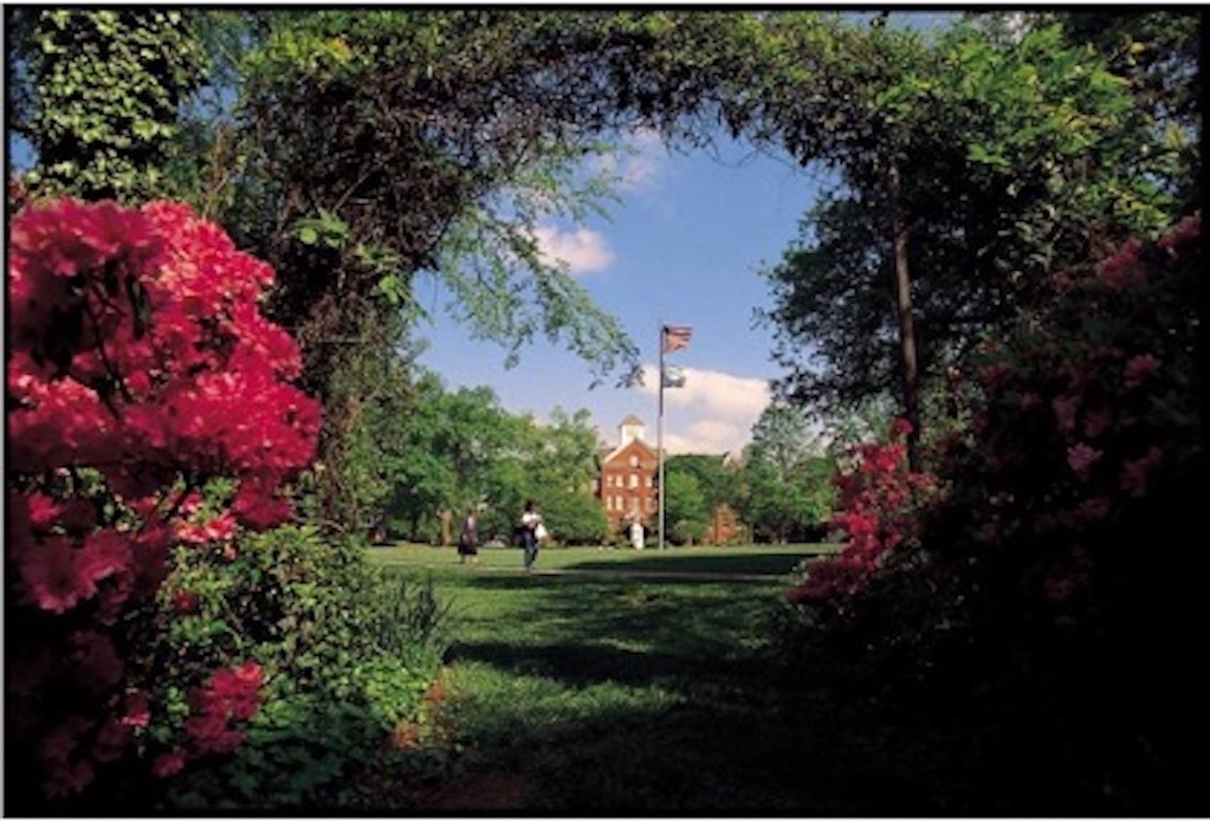

Academic Program Review
Guidelines for the External Review Team

Each academic program or department selects 3 professional peers from within the discipline to serve on an external review committee. One member of the committee is appointed as chair. The chair assumes responsibility for the final version of the team's written report and communicates with the Office of Institutional Effectiveness regarding requests for additional information or delays in submission.

Committee members are expected to:
- Use professional judgment and maintain integrity in their role on the review committee.
- Maintain confidentiality and refrain from discussing the program’s Self-Study or evaluation outside of deliberations or discussions within review meetings or between review team members, the department or program chair, faculty or staff.
- Work collectively and as a team to review materials, obtain needed information, and engage in all interviews and meetings.
- Deliver accurate and fair findings and recommendations that reflect the consensus of the review team.

What to Expect at the Onsite Visit
The campus site visit is an opportunity for the program to further engage in the reflective process with peers from other institutions. With this in mind, program faculty, staff, students and administrators as well as select members of the community meet with the external evaluators over the two-day visit. Separate meetings are scheduled with the various college constituents and may be organized as appropriate.
Meetings are scheduled in small private groups based on attendee functions or roles. Program leadership and college administration are not present during these small group meetings. Recording of meetings is also discouraged.
Reviewers are encouraged to read the department’s Self-Study and review any supporting materials prior to the campus visit. This will assist the team in composing questions in preparation for the campus visit. The team may also begin developing their report outline.
During the campus visit, the review team should also prepare to present any preliminary recommendations or thoughts during a close-out meeting on day 2. This verbal report should not be exhaustive, but only provide a general overview of the team’s initial impressions.
Preliminary Meeting prior to the On-Site Visit
Prior to the campus visit, the review team will meet with a member of the Institutional Effectiveness Office. This organizational meeting provides an opportunity to meet formally with the other committee members and to review information in preparation for travel, meetings and the final report.
- Introduction of committee members and a discussion of assignments and responsibilities.
- Review of the responsibilities of the chair and the team as a whole.
- Review of the responsibilities of the committee.
Welcome Meeting-Day 1
The welcome meeting is an opportunity for the program chair to greet the external review team, welcome them to campus and share any preliminary information and logistics. This may occur over Breakfast, but this will be determined by the department.
Orientation Meeting-Day 1 .
The Orientation Meeting on day 1 provides an opportunity for formal introductions and a review of the self-study and onsite visit goals and objectives. The meeting is attended by the program chair and vice or co- chair and the Provost (or her designee), members of the department and/or the committee responsible for completing the self-study.
The chair and the provost provide the initial greeting and introductions. The meeting is then open to the reviewers to ask questions regarding their roles in the review process and expectations during the onsite visit. The reviewers may also ask general and broad questions about the program, the college or the self-study report.
Meeting with Administrators-Day 1
Meetings with campus administrators are typically scheduled early on day 1. Attendees include the Division Chair and/or other members of the college or program leads.
Meetings with Faculty Members
Depending on the size of the academic unit, there will be two or three small group meetings with faculty grouped by rank or tenure status. If appropriate, evaluators may also have a formal meeting with the faculty members/committee who wrote the program’s self-study report. The department chair should not be attendance.
Meeting with Program Staff-Day 1 or Day 2
The review team will also meet with any program staff. This includes any executive or administrative assistants, program coordinators, operations managers or other support staff.

Meetings with External Faculty, Alumni or Campus Constituents
External faculty, corporate partners, and/or community leaders that can speak to specifics regarding the program will also meet with the review team. The program chair or faculty designee may be present at the beginning of the meeting to make introductions, but as above will not be present during the duration of the meeting.
Meetings with Students and Alumni
Reviewers will also meet with a diverse mix of students currently in the program as well as program alumni.
Meetings with alumni are scheduled separately and may involve online/video meetings.
A departmental representative or the chair of the external review team (if one is designated) will provide introductions, explain the purpose of the visit and the reason for the meeting before the meetings starts.
Tours and Presentations
A tour of the program facilities including teaching spaces, offices, and any labs or research areas will be given. The program may also opt to offer a tour of the campus or have research presentations by students (and/or faculty or staff if warranted).
Breakfast
Breakfast is generally open to the discretion of each review team member unless otherwise stated in the agenda.
Lunch
Lunch is provided for the review team on day 1 and day 2.
The review team has the option to dine alone if time is needed to work on the report outline. This will be discussed during any planning meetings.
Dinner
In general, the review team members dine together on day 1. This allows time for the team to review the day’s events and meetings, confer over notes, discuss the review report and prepare to present any preliminary findings during the close out meeting on day 2.
The department has the option of providing dinner for the reviewers on campus or providing dinner options off campus. This will be discussed during the preliminary meeting.
Debriefing Meeting
If needed, a debriefing meeting may be scheduled at the end of day 1 or start of day 2. This is an opportunity for the program chair and/or the program review committee (that completed the Self-Study) to answer any questions that the review team might have following day 1 meetings.
If a debriefing meeting is not required and if time permits, the review team may opt to reserve time a begin drafting their final report.
The Office of Institutional Effectiveness will provide procedures for writing the report.
Exit/Close Out Meeting:
The exit or close out meeting occurs at the end of day 2 and follows any small group meetings with faculty, students, staff, etc. In this final session, the external review team meets with the program chair, the provost, the division chair, members of the program review committee and/or other faculty and/or a representative from the Office of Institutional Effectiveness.

- The provost opens the meeting and invites the review team to provide an oral report of any preliminary recommendations or findings.

- The review team is allowed to present without discussion or questions. The review team may also provide any consultative comments that may not appear in the final written report.

- The program chair or the provost then provides any closing remarks before the review team departs for their hotel or the airport.

The review team will receive any final directions regarding completion of the report, submission of documentation for reimbursement via email from the Office of Institutional Effectiveness.

