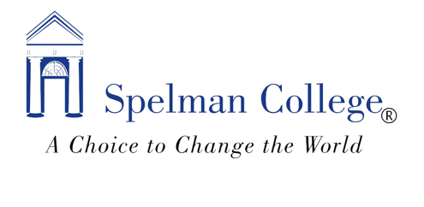
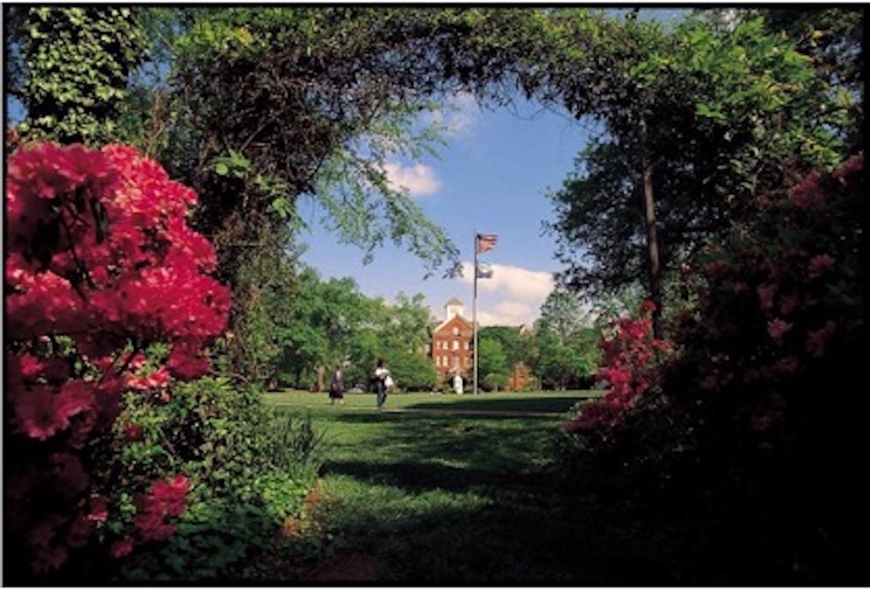

Academic Program Review
External Review Team Report Guide

This document provides general guidelines for completion of the external committee’s final report. The committee is not required to use this outline, but it may be of assistance in structuring the review and final document. Each section of the outline also presents keys questions that can be addressed in the review.

The Structure of the Program’s Self-Study Report

Academic Program Review at Spelman College centers on assessing two major themes: Program Quality and Program Effectiveness which are covered in the first two sections of the Self-Study report.

Program quality refers to specific attributes of the program including program accreditation (if applicable), program mission alignment, program resources (fiscal, human and physical) and the methods and processes for ensuring quality within these areas.

Program effectiveness examines the curriculum, student learning outcomes, student success measures, and program assessment and how well each of these are addressed by the program.

The program asks that the committee keeps these themes in mind when preparing the external review report and making recommendations.

The final section of the program’s Self-Study Report summarizes key findings, implications and the future goals and priorities of the program. The program may outline specific issues that are of importance to the success of the program in this section.

Report Writing Tips for the External Review Team

- Consider identifying time before, during and after the On-Site Visit dedicated to organizing information and writing the report.
- Beginning with a general outline based on the sections of the Program’s Self-Study report can be helpful.
- The 7–10-page written narrative should synthesize the views and recommendations from all external reviewers.
- Include an Executive Summary.
- Highlight the major findings related to the quality and effectiveness of the program and provide detailed recommendations; explicitly tie these recommendations to observations or presented evidence.
- Identify and discuss any strengths, areas of improvement or needs of the program.
- Group recommendations under a few general categories.
- Indicate which recommendations should be prioritized.
- If bullet points are used, expound/fully describe each (bulleted) point.
- Identify any recurring themes and their significance.
- To expedite the completion of the report, the review team is encouraged to have an outline of the report completed before the end of the On-Site Visit.
- The team may decide to have specific members focus on specific areas of the report.

The final draft of the External Review Team report should be submitted within 2 weeks of the team’s campus visit. Send a pdf copy to Felisha White (felishawhite@spelman.edu) and carbon copy (CC) Dr. Myra Burnett (myraburnett@spelman.edu).

Suggested Outline for the External Review Team Report

The following sections present a general outline for the external review team’s final report.

- Executive Summary
Provide a brief overview of the review team’s major findings, recommendations and commendations for the program.

- Review Processes and Activities

- Briefly summarize the activities of the committee. Discuss any preliminary planning related to the onsite visit meetings and writing of the report.
- Detail the interactions with program administrators, faculty, staff, and students and any departmental or facility tours.
- Briefly site any supplemental materials requested or reviewed by the committee (e.g., data, surveys, analytics, web links, committee-administered surveys, etc.).

- Assessment of the Report
This section summarizes the external review team’s assessment of the program’s self-study report and supporting evidence.

- Discuss the key elements of the self-study report and whether information was sufficiently and appropriately presented.
- Assess supporting data/evidence provided in the report.
  - How relevant was the evidence in addressing reflective questions in the self-study report?
  - To what extent was evidence provided that related to assessing student learning outcomes at multiple (e.g., course, program, institutional) levels?
  - How consistent was/were the analysis(es) and conclusions presented with the evidence?
- Provide an overall assessment of the extent to which the self-study report was helpful and/or effective in framing lines of inquiry for the program review visit.
  - What evidence was most helpful?
  - What evidence was not provided that would have been helpful to include?
- Was the program thorough in its summary and analysis?

- Program Quality: Strengths and Weaknesses
In this section consider the information and data presented regarding program quality.

- Provide an overview of the program strengths, weaknesses, opportunities, and threats as it relates to mission alignment, program offerings (majors and minors), program resources (fiscal, human and physical) and the methods and processes for ensuring quality within these areas.
  - Are the mission and scope of the program suitable given the current number of faculty, students and the resources available to the program?
(e.g., Are there too many or too few areas of specialty/emphasis within the program(s) given the size of the faculty and number of students?)
  - Assess the program’s structure and organization. Do faculty and staff qualifications, appointments and workloads support the program, it’s majors/minors? Examine faculty research and scholarship activities.
  - Is recruitment and retention of program faculty and staff adequate?
  - Examine the program’s financial and physical resources.
  - Based on the evidence, what aspects of the program and majors are notable as areas of strength and/or models of excellence?
  - What are the growth areas for the program? Are there specific degrees (e.g., majors, tracks, minors) that it would be advantageous to develop, eliminate, or modify?
  - Are the majors and minors supporting the needs of the students?
  - To what extent are adequate resources available to support high quality teaching and learning?
  - What resources and systems are in place to support student success in this program?
  - What supporting evidence can be drawn from interactions with faculty, staff, administrators and students? Were there any recurring themes?

- Program Effectiveness: Strengths and Weaknesses
Consider the information and data presented regarding program quality. Provide an overview of the program strengths, weaknesses, opportunities, and threats as it relates to the curriculum, student learning outcomes, student success measures, and program assessment and how well each of these are addressed by the program.

- Discuss the program curriculum and how it meets or does not meet stated program learning outcomes. Review the curriculum map. Is the sequence of courses appropriate and effective?
- Discuss the program’s assessment of student learning outcomes and use of annual assessment reports to improve the student learning experience. Are there particular areas of strength or weakness? To what extent are processes in place to identify, understand, and address potential disparities in student learning and program outcomes?
- How effective are the program’s advising processes and efforts? Do these processes support students’ academic progress? Is there adequate advising for the majors and minors?
- Is the program meeting student success measures centered around enrollment, retention and graduation?
- How effective is the department in its use of assessment strategies? Does the department appropriately use assessment results in their decision making & operational planning process? To what extent are processes in place to identify, understand, and address potential disparities in student learning and program outcomes?
- Discuss the program’s ability to prepare students for a career path. Consider the various factors that impact these efforts.
- How effective are recruitment efforts of the program?

- External Review Team: Final Recommendations and Conclusions
This section details the review team’s recommendations and conclusions.

- Highlight any exceptional aspects of the program as well as provide recommendations on areas of improvement and future directions that focus on the overall quality and effectiveness of the academic program.
- Indicate which recommendations should be prioritized and if possible, why. Explicitly tie these recommendations to observations or presented evidence. This includes specific actions to be taken and may include recommended deadlines.
- Prioritize each recommendation and distinguish between short- and long-term goals. Recommendations may be directed to the program and/or college administration, faculty or staff.
- If the program identified specific issues in the self-study be sure to directly address them.
- The team may also identify any additional concerns not discussed in the self-study report that should be addressed.

